**DEMO**

***Creating and Connecting an Instance:***

**Step 1: Open the AWS management console, open services drop down and click on EC2 under the compute category.**

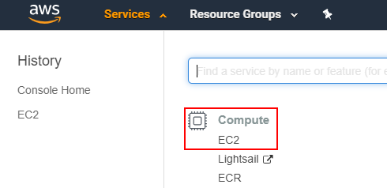

The basic steps to follow in order to create an amazon EC2 instance is depicted in an image below.

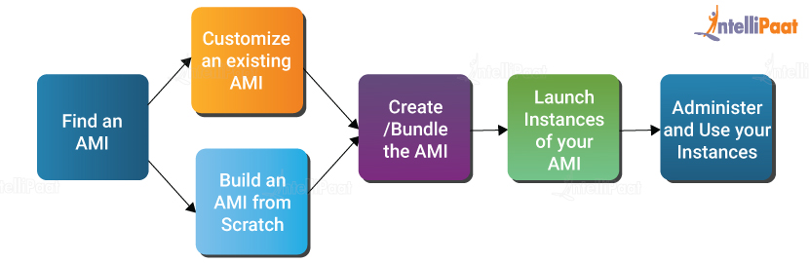

**Step 2: Creation of an Instance**

* First click on Launch Instance

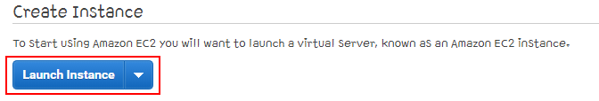

* Now, in the Choose AMI section, scroll down and choose Ubuntu and click Next

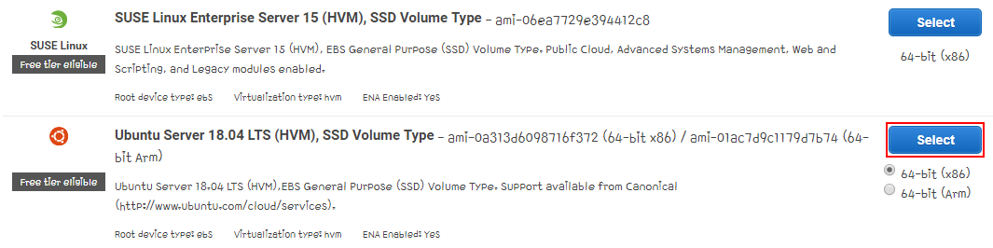

* Choose the free tier eligible t2.micro Instance and proceed with Next

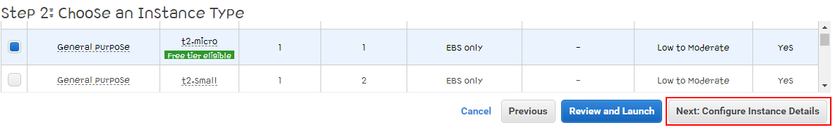

* Configure Instance details and then click Next.

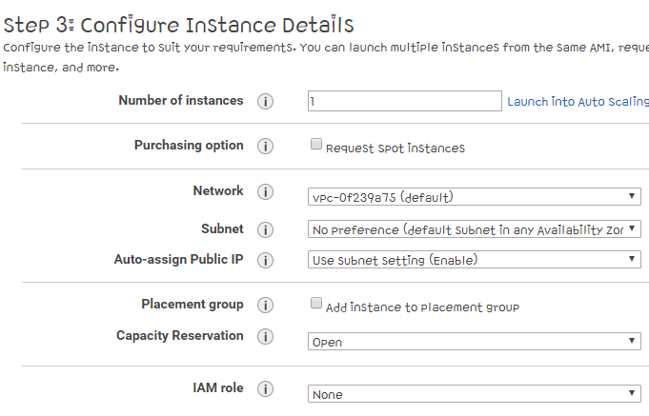

* Next is adding storage and you don’t need to change the size because for a basic ubuntu instance 8 GiB

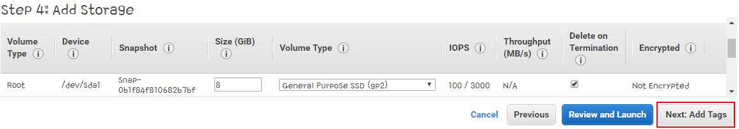

* Now add a tag with the attributes Key and Value, name them as it is in the image below.
* The Key and Value pairs are to identify the particular Instance while it is running.

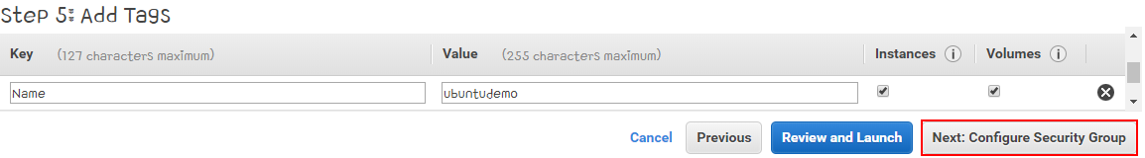

* Now proceed with the next step, Create a new security group then click next

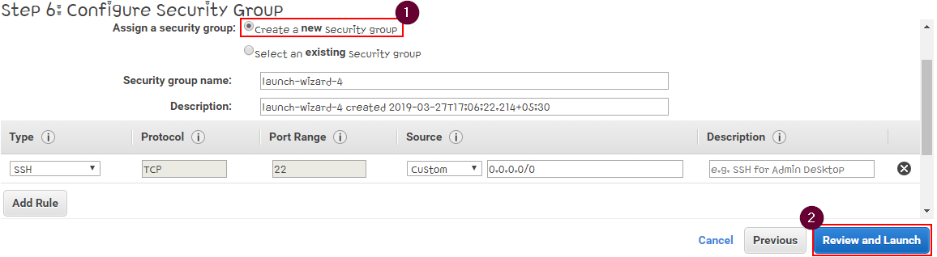

* Review your Instance specifications once and then launch it.

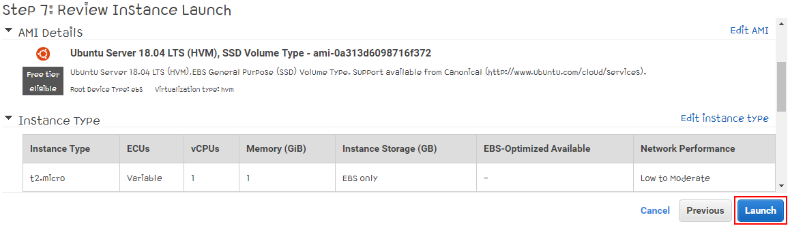

**Step 3: Creating a new key pair**

* Choose create a new Key Pair option from the popup box, give the name for the Key Pair and then download the Key Pair. Proceed with Launch Instances.
* Keep the download Key Pair file in a safe location so you can access it later

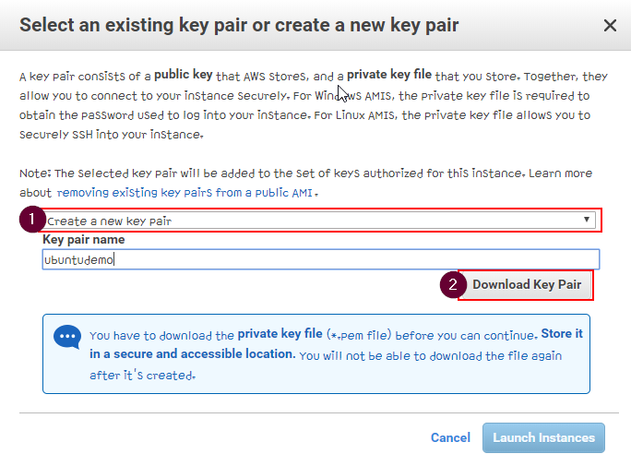

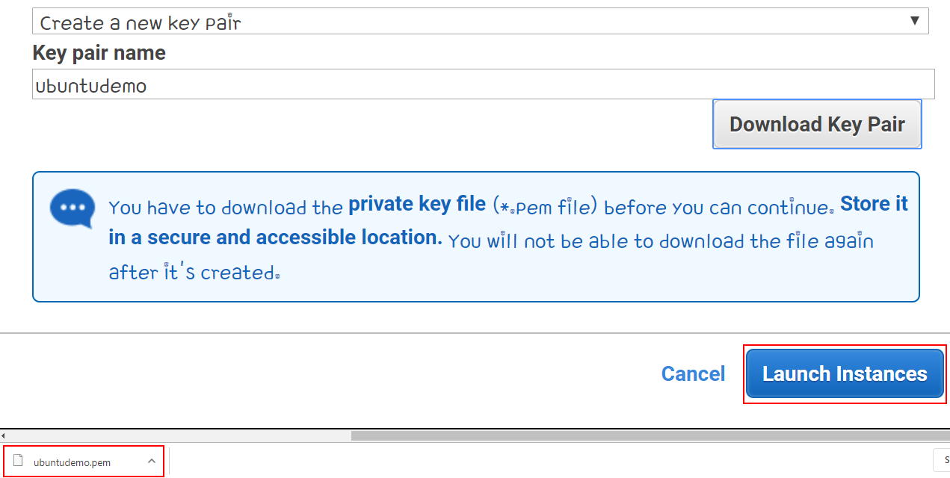

**Step 4: Viewing Instances**

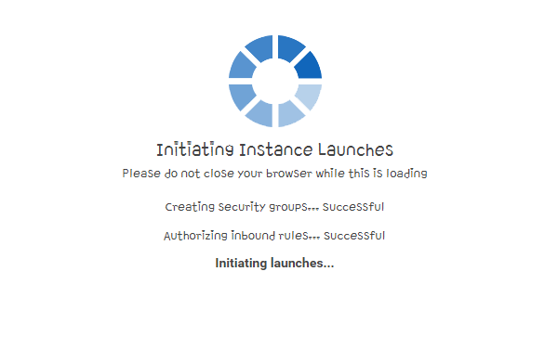

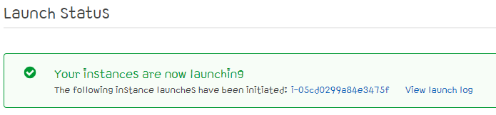

* Wait till the launch is initiated, then Click on instances under INSTANCES and view the instance which you created

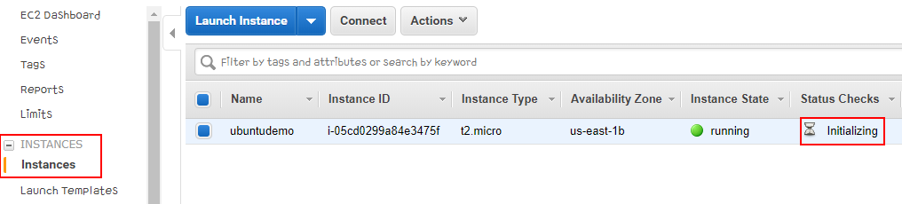

* Wait till your Instance initializes. That is still your 2/2 checks are done.

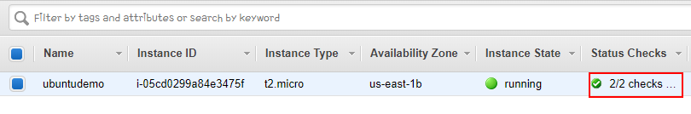

Now it gets interesting, here we are going connect the Instance using an SSH client and then Hosting our own Website.

**Step 5: Connecting the Instance through an SSH client**

* Download PuTTY : a free SSH client

Website link - <https://www.chiark.greenend.org.uk/~sgtatham/putty/latest.html>

* Choose 32 or 64 bit according to your system’s specs. Then Install it like you install any other application on your system.

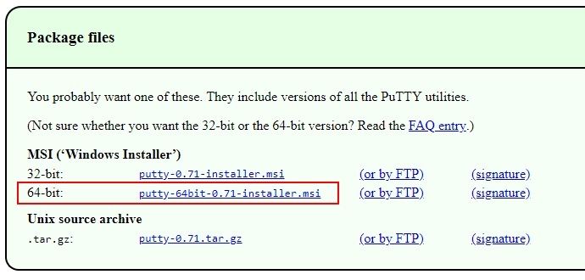

* Install PuTTY

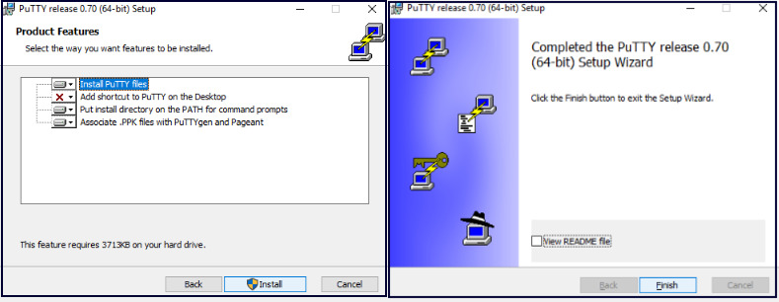

* PuTTY only accepts Private key files with extension “.ppk”, so we have convert our ubuntudemo.pem to an .ppk extension.
* Now, open PuTTYgen and load the “ubuntudemo.pem”. Then a dialog box appears and give OK.

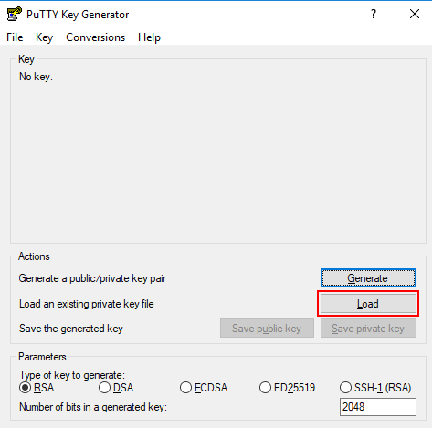

* Then click on save private key and proceed with a Yes in the dialog box. After that store it in location where you can access it easily.

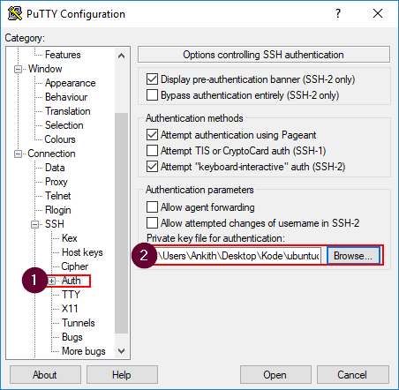

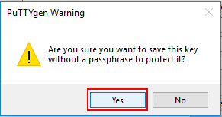

* Open PuTTY, type ubuntu@”your public ip” which you can find in the description tab for your instance.

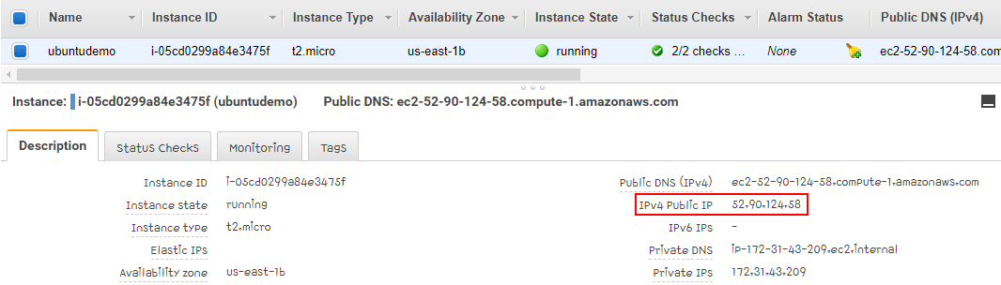

* First, type the Host Name in the box with the port number remaining 22.

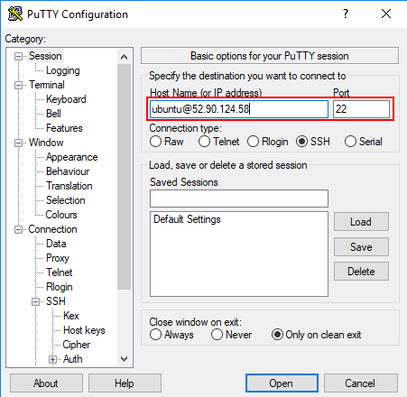

* Secondly, Go to Connection → SSH → Auth. Now click on Browse and add the .ppk file which you created.

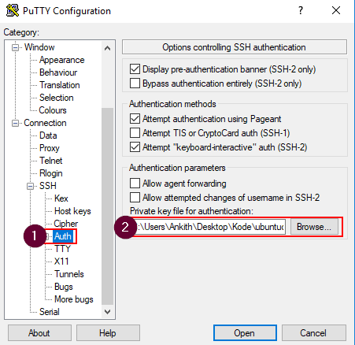

* Click Open. Then press Yes on the PuTTY security alert box.

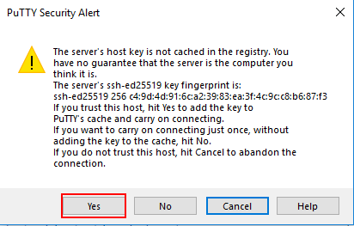

* **Now you have successfully launched your Ubuntu Instance!**

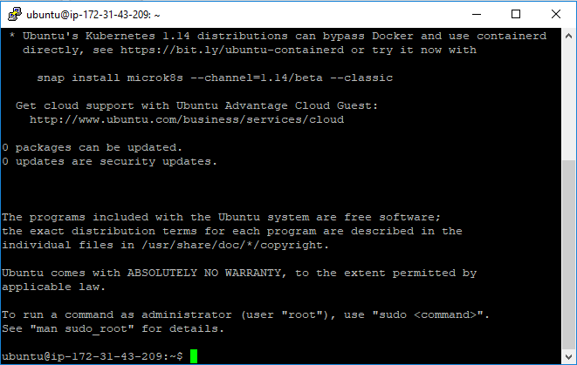

**Step 6: Running a simple HTML page via this instance.**

* First update the Ubuntu instance using this command



* Then install apache2. Apache2 is a web server which is commonly used in Linux systems.



* Type these commands to enter into that directory and check whether index.html exists



* Go back to your instances page, click on the “launch-wizard-4” under security groups

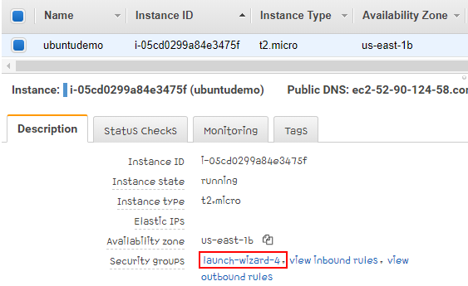

* Go to Inbound and click on Edit. Then add a HTTP rule with Source as “Anywhere”

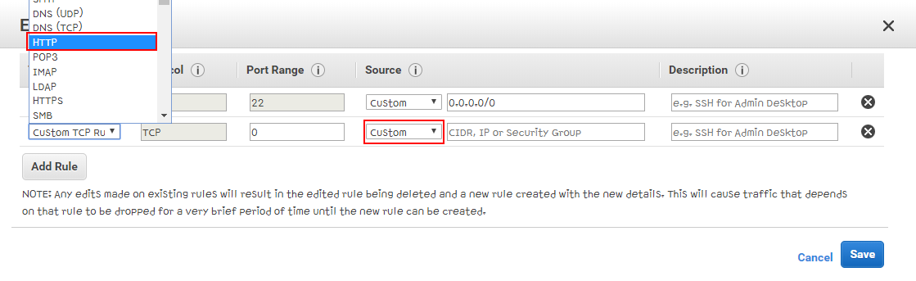

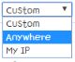

*Keep the Source as Anywhere*

* On your browser, Use your public IP address and put it in the URL box and run.
* You have now successfully hosted your first website via a Cloud Instance.

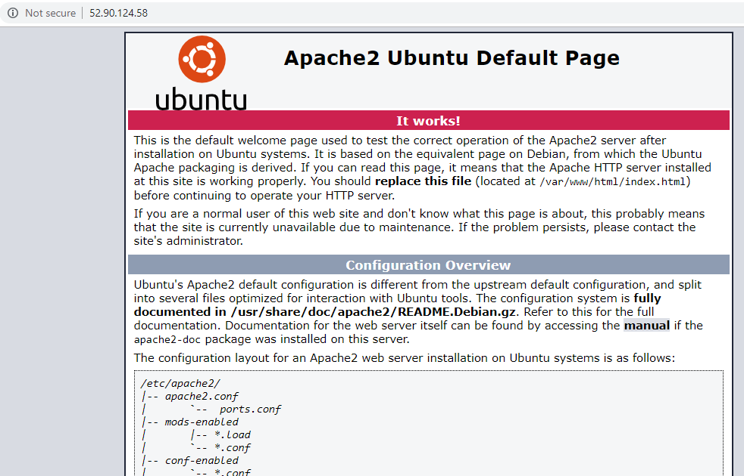

* Let us now edit and run our own HTML page instead of the Apache2 default page
* 
* 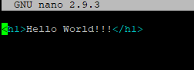
* 
* For one last time, run the Public IP address of your instance in the browser

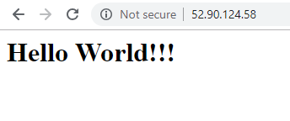

**Congratulations! You have created your first Ubuntu Instance and have run your Webpage on it!**

Continue reading to learn more about AWS.